Project Report: AWS SQS and Lambda Integration

1. Project Introduction
This project demonstrates how to use Amazon Simple Queue Service (SQS) along with AWS Lambda to automate message processing. In this setup, messages are first stored in an SQS queue. Whenever a new message arrives, it automatically triggers a Lambda function, which can then process the message and log the results.

2. Objectives
- To automate message processing using AWS Lambda.
- To use SQS for message queueing, ensuring scalable, reliable, and decoupled communication between components.
- To trigger Lambda functions automatically upon message arrival.

3. Architecture Overview
The core architecture follows a simple flow:
- Step 1: Users send messages to the SQS queue.
- Step 2: Lambda is configured with SQS as its trigger.
- Step 3: Each new message in the queue triggers the Lambda function.
- Step 4: Lambda reads, processes, and logs the message to Amazon CloudWatch.
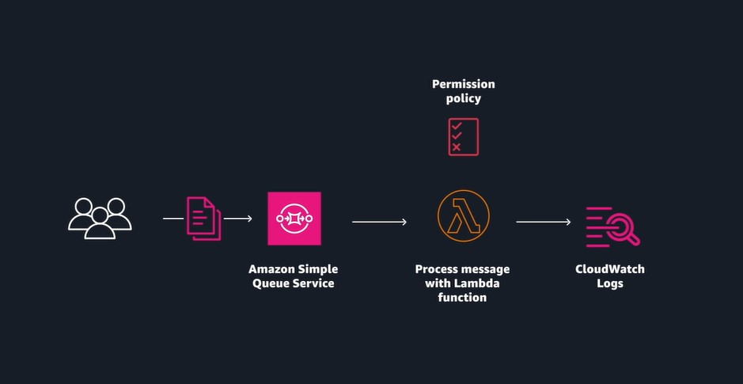

4. Implementation Steps

A. Creating the SQS Queue
A standard SQS queue named sqsQueue was created using the AWS Console. This queue acts as the message storage and is configured to allow sending and receiving messages.
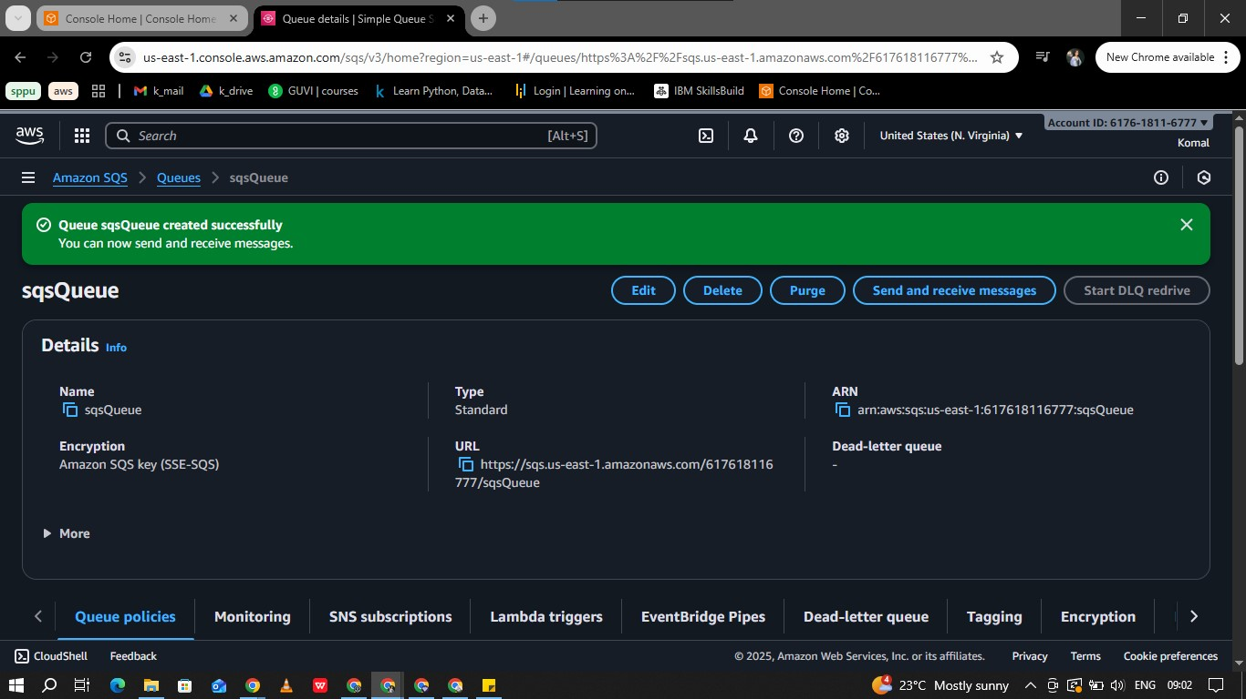

B. Sending Messages to SQS
Messages were sent to the sqsQueue using the AWS Console interface. You can view sent messages and their details.
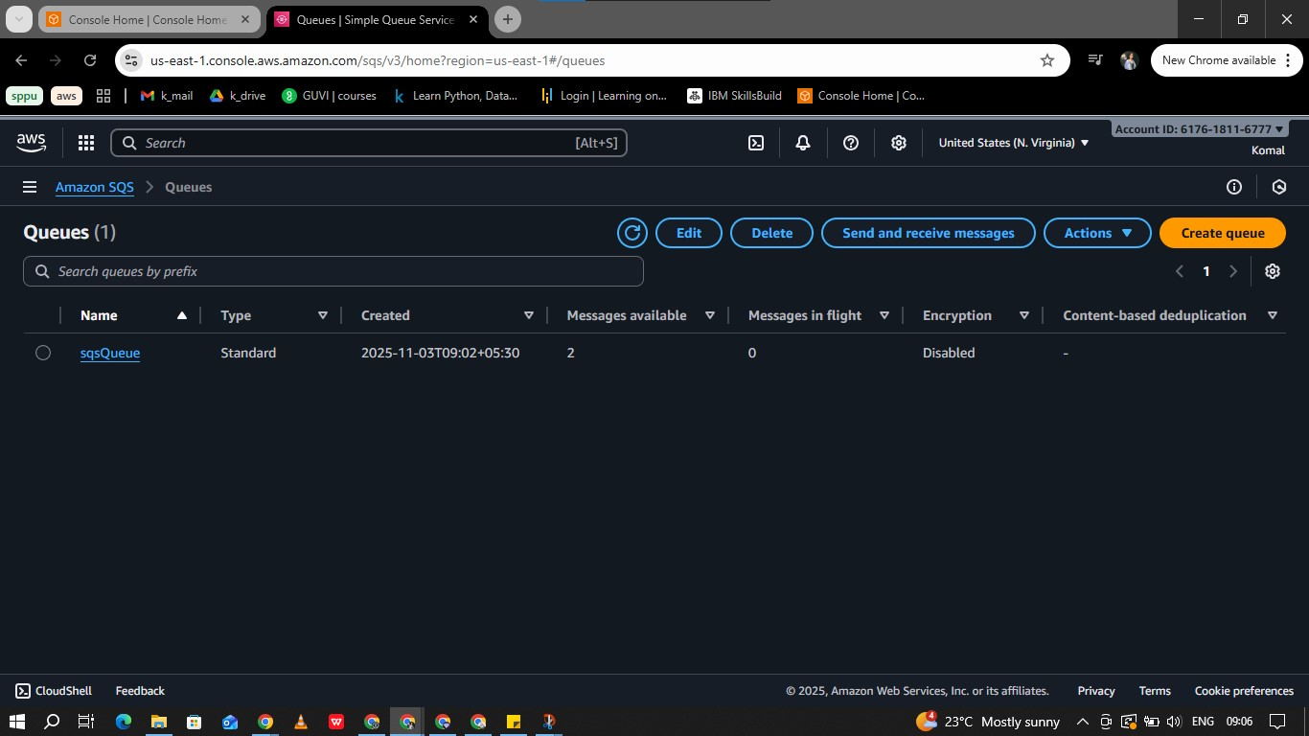

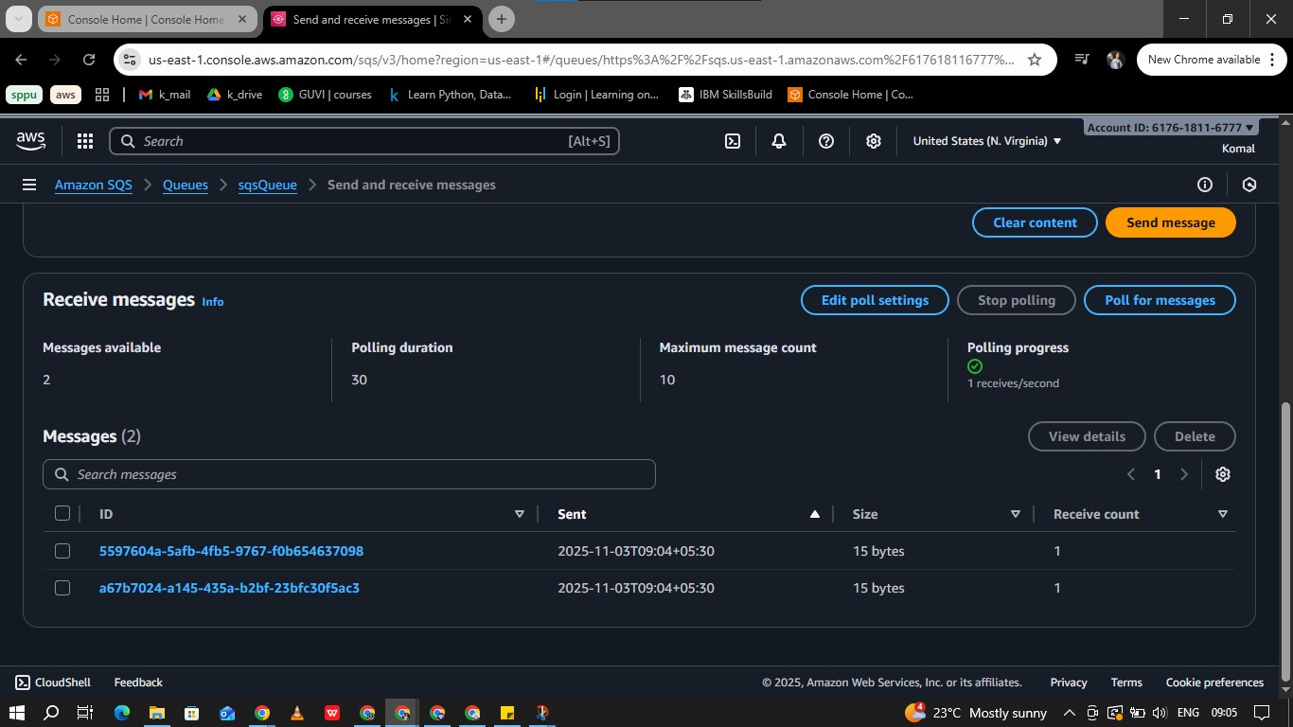

C. Lambda Function Setup
A Lambda function named lambdaFunction was created using Node.js. This function is configured to be triggered whenever a new message appears in the SQS queue.
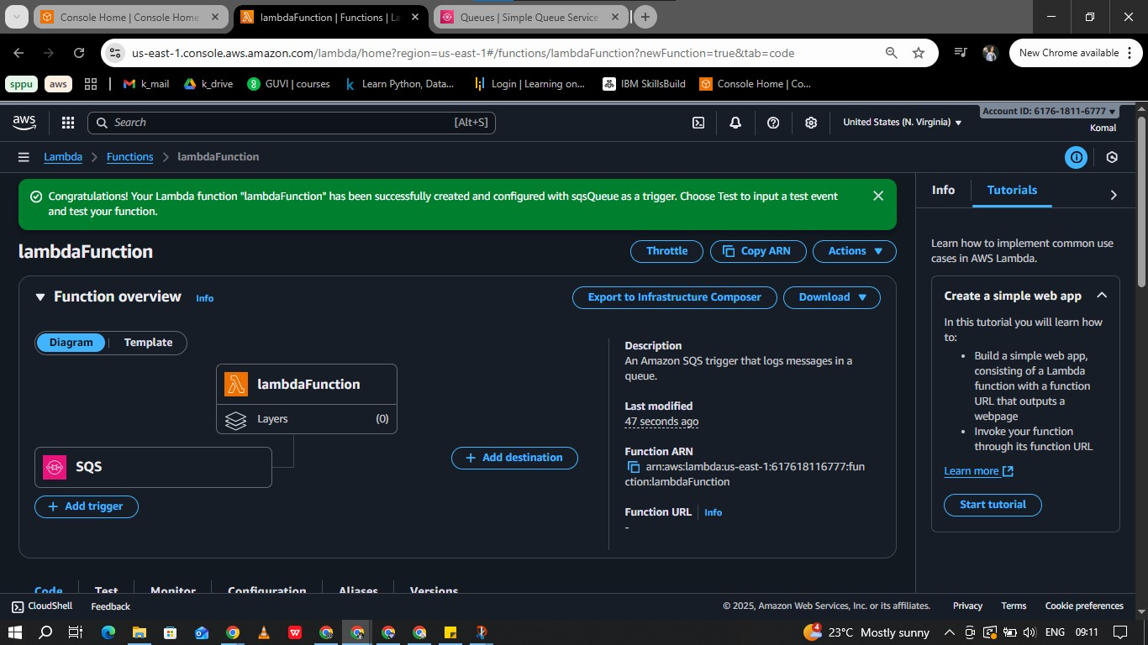

D. CloudWatch Logging
CloudWatch was used to monitor and log the Lambda function's execution and the messages it processed.
- Each time Lambda is triggered by a new SQS message, relevant details are logged such as message ID, content, and Lambda execution status.
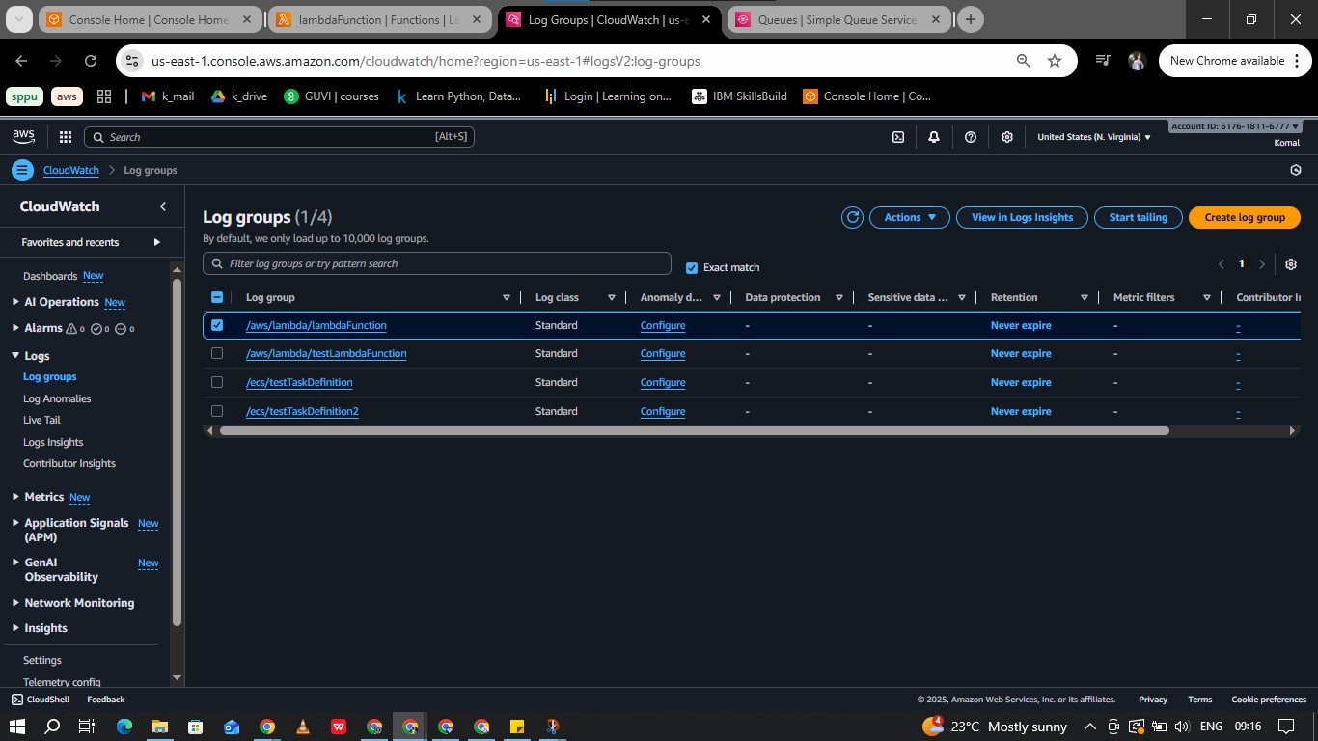
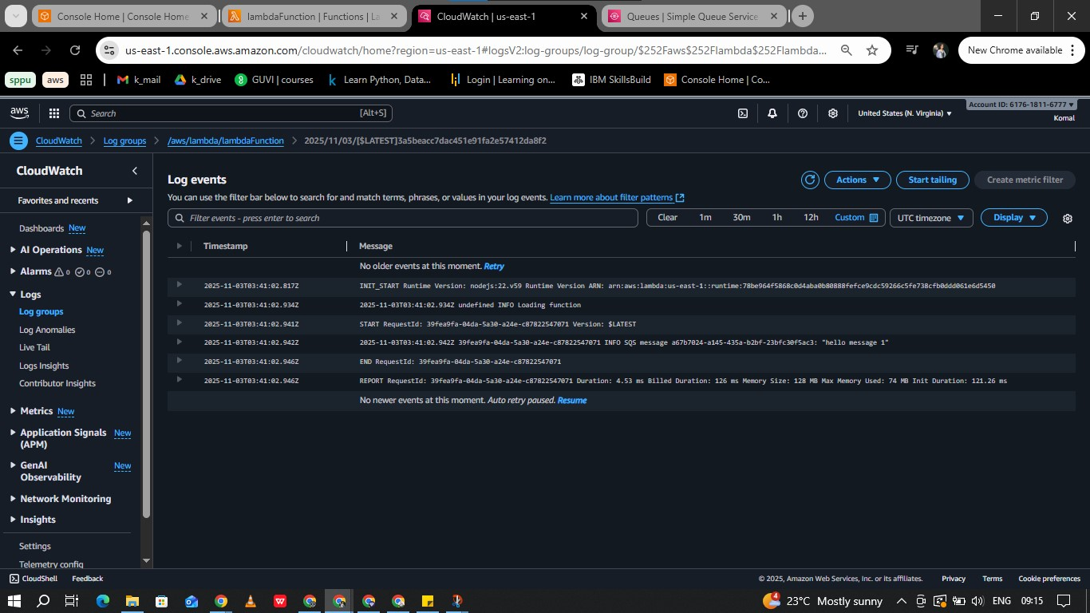
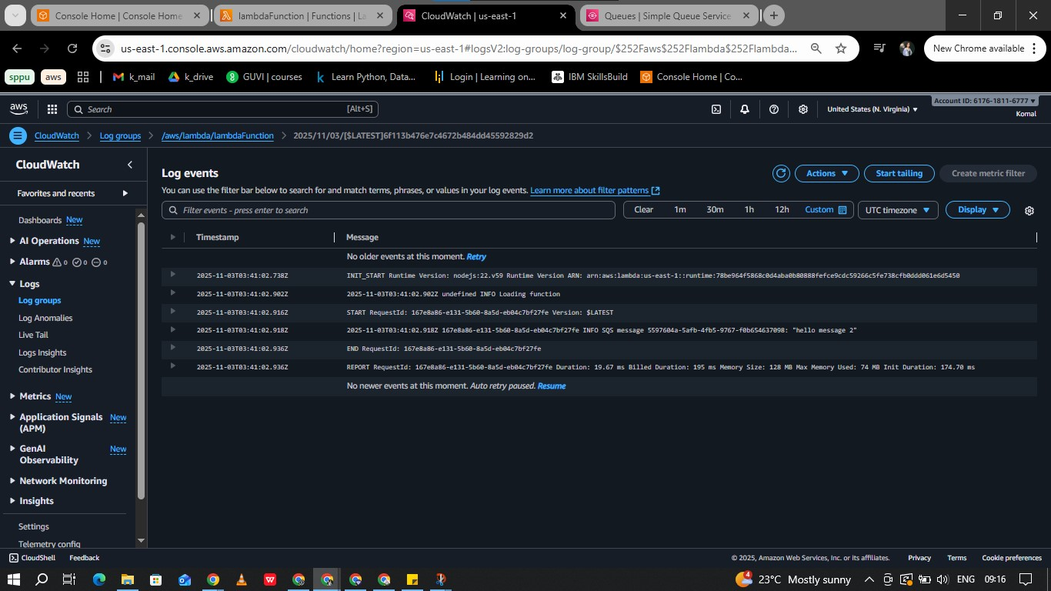
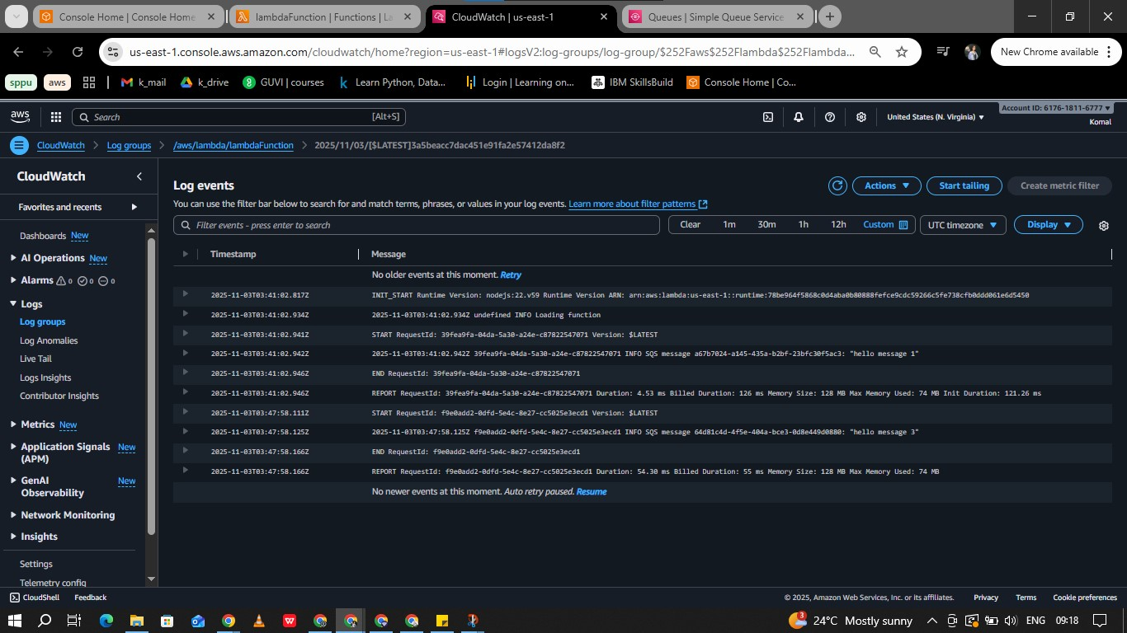
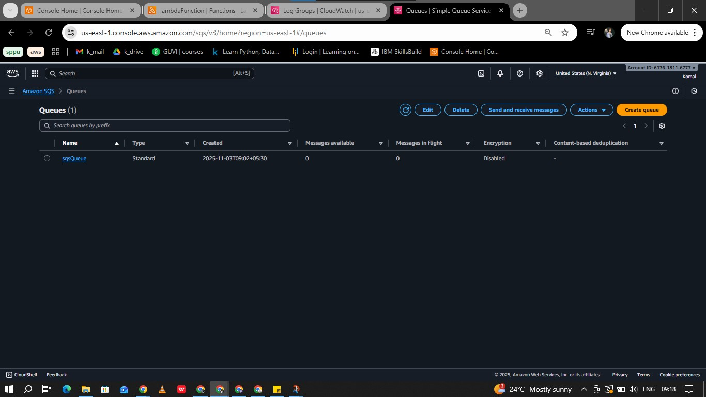

5. Results
- The integration works smoothly: new messages in SQS automatically trigger Lambda processing.
- Messages are successfully logged for each Lambda invocation.
- The workflow is verified using screenshots, showing queue creation, message sending, Lambda configuration, and CloudWatch logs.

6. Conclusion
This project makes it easy to handle messages automatically using AWS SQS and Lambda. Whenever a message comes in, your AWS setup processes it for you. You don’t have to manage any servers. The steps and screenshots make it simple for anyone to follow and use the same method.

